GitHub guide: how IWP uses it

Created 5/28/2015 by Jacqui Young

Includes:

1. Signing up for GitHub
2. Downloading GitHub and saving a new document
3. Opening a current document in GitHub
4. How to make a folder/ branch in GitHub
5. Signing up for GitHub
6. Go to GitHub.com and sign up, I reccommed making your username the same username that you have through Messiah College (ie. jy1189).
7. You should get a confirmation email.
8. After you are all signed up, click on the search bar in the top left hand corner and type in “**intelligent water”**
9. **Downloading GitHub and saving a new document**
10. Download github on <https://github.com/> (you may need to get Paul Myers or IT to give you permission to download it onto a school computer)

(IT’s number: 717.796.1800 x3333)

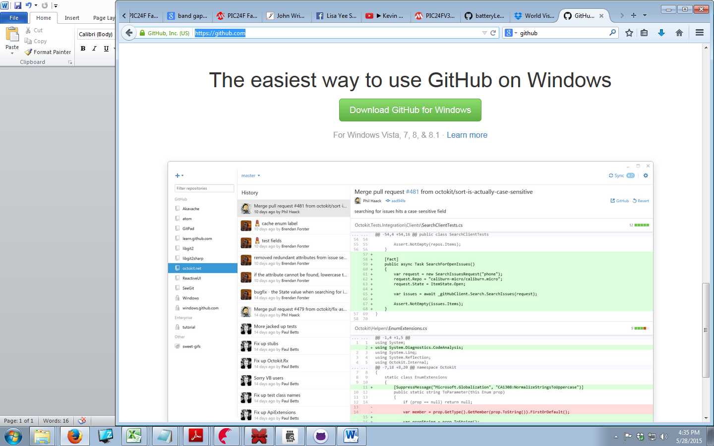

1. Open up the GitHub **folder** which should now be on your desktop

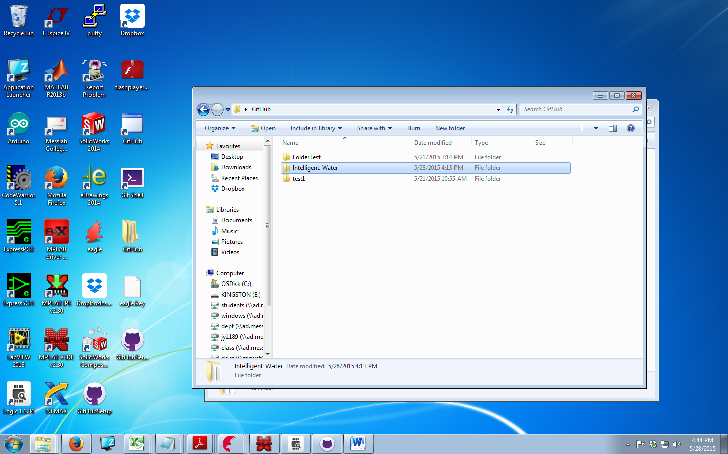

1. Select where you want to save your new file

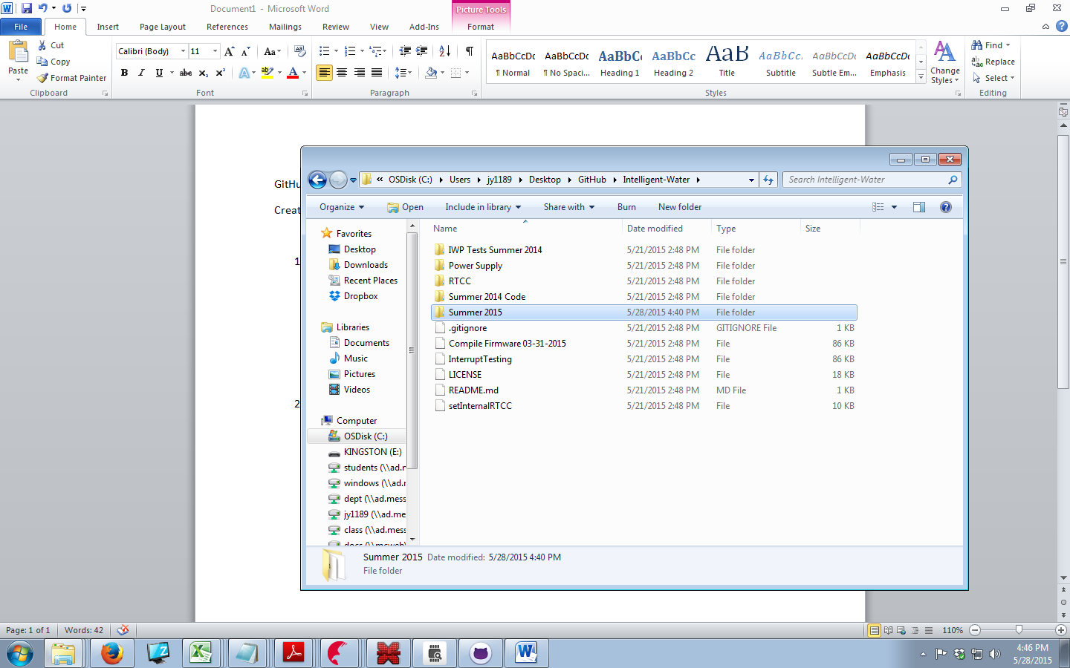

1. Now open up GitHub on your desktop, and Sync the file.

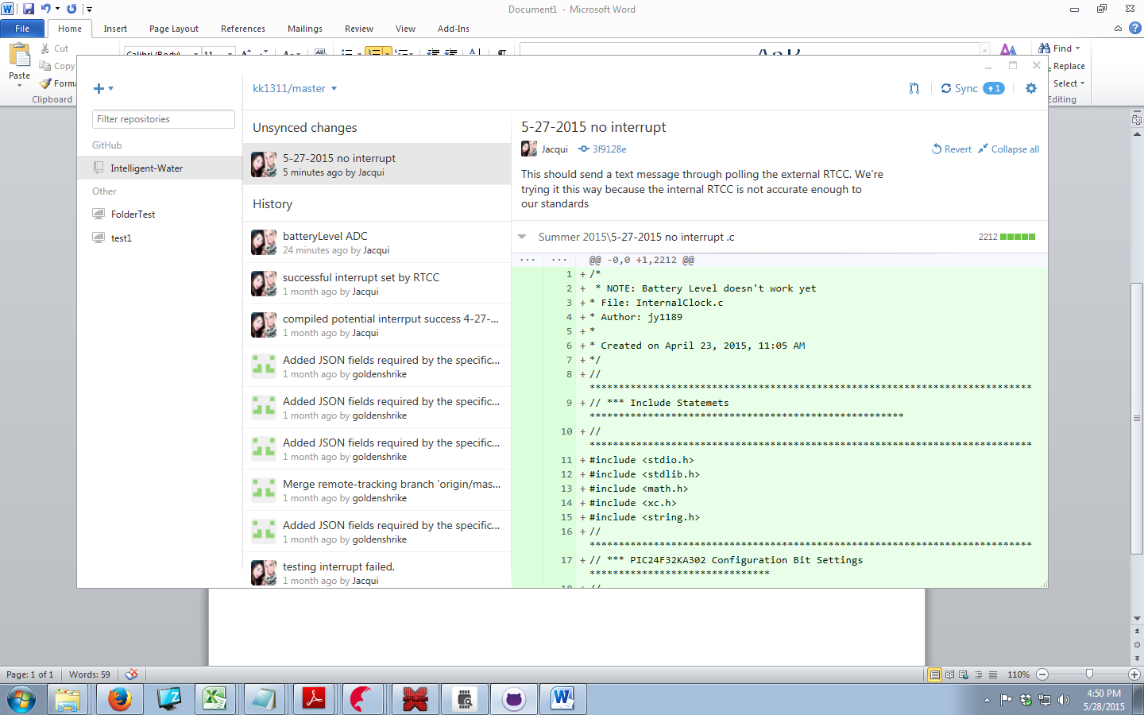

1. **Opening a current document in GitHub**
2. Open up github.com and log in.
3. Click on our project

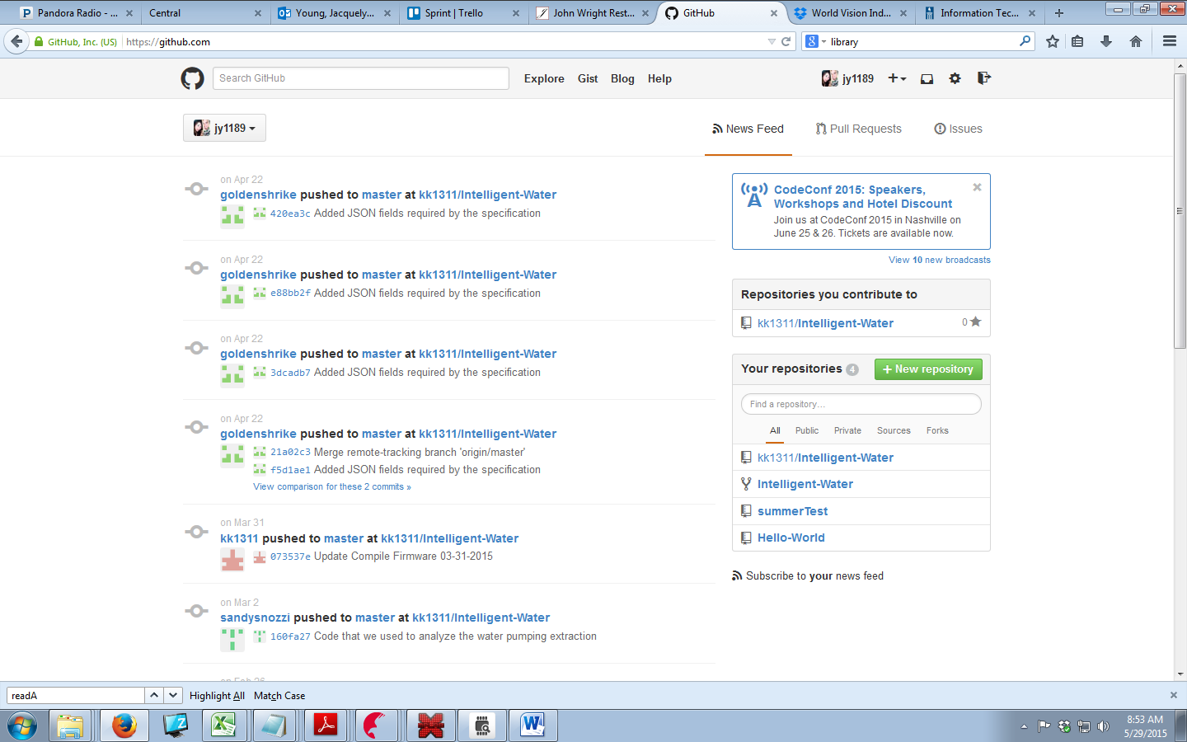

1. Click on the branch (folder) you want

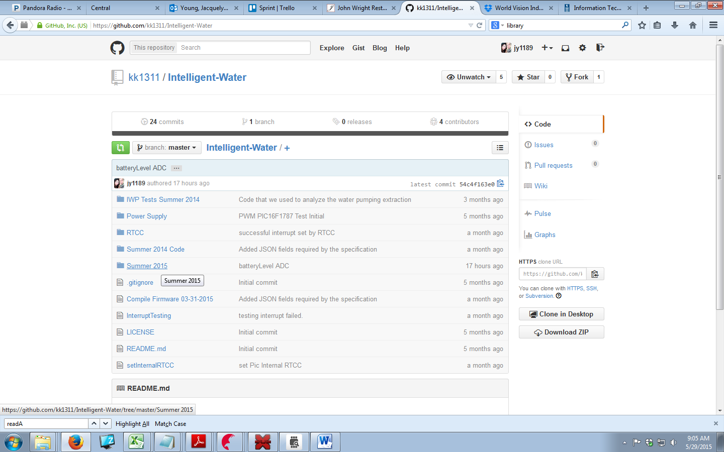

1. Add a mini title for changes made with a detailed description to go underneath to help those in the future. After you have completed this Commit the file to master.

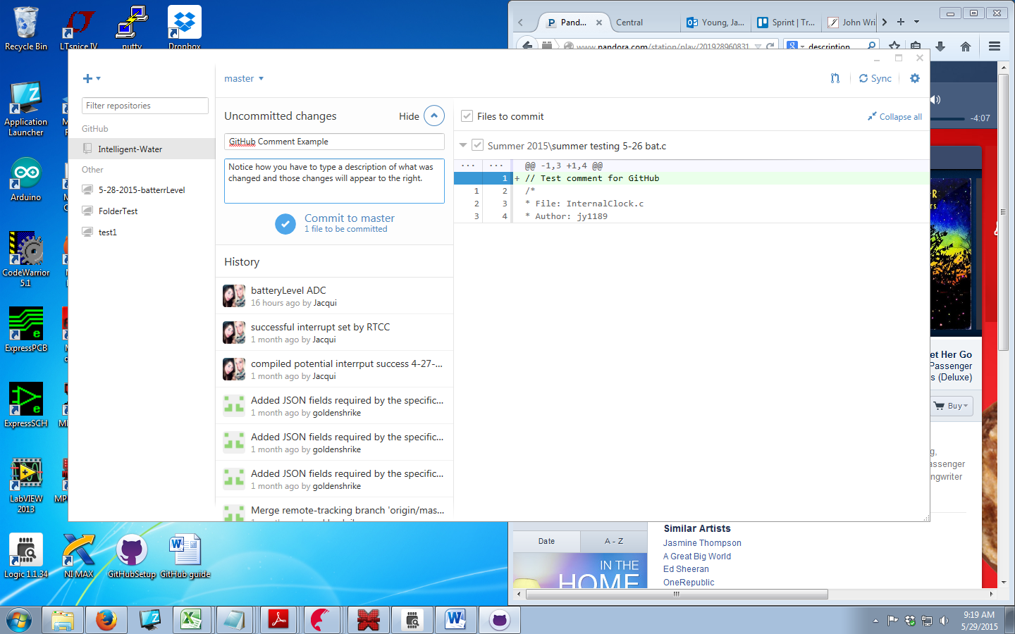

1. Remember to Sync the file!

How to make a folder/ branch in GitHub

1. After you downloaded GitHub you should have also downloaded a GitHub folder. Open it. Then open up the Project you want to make a folder (aka branch) in. Right Click > new > Folder

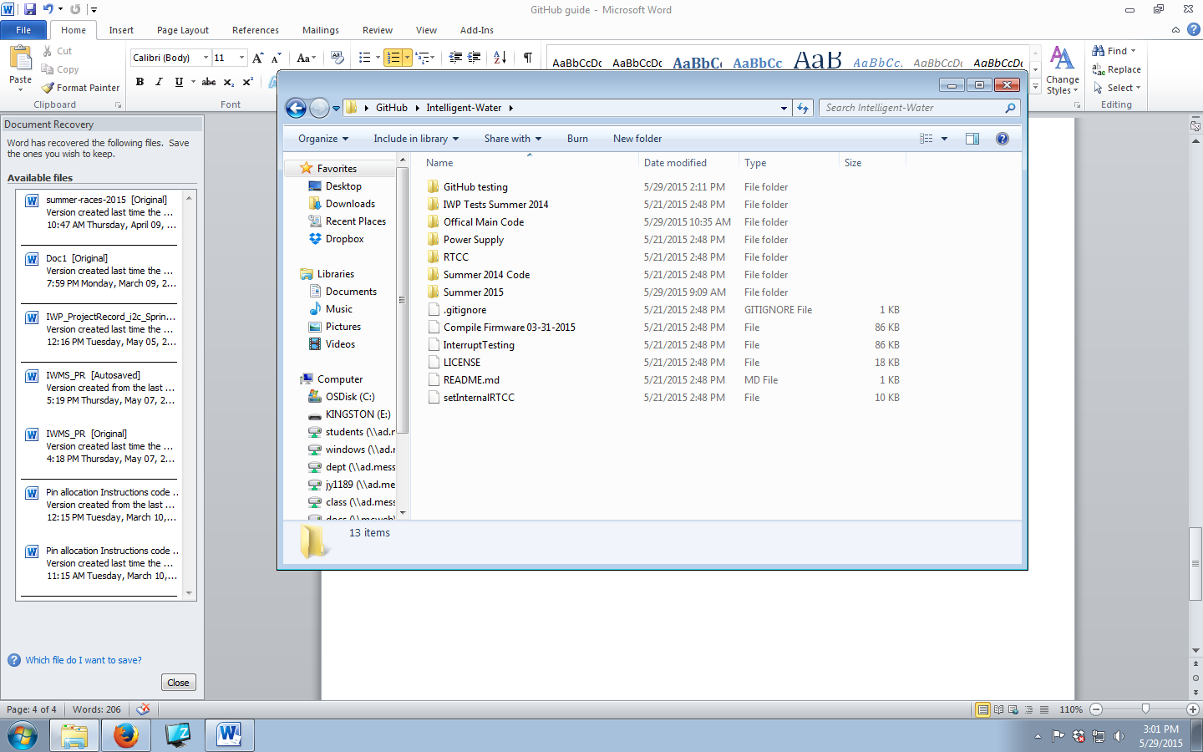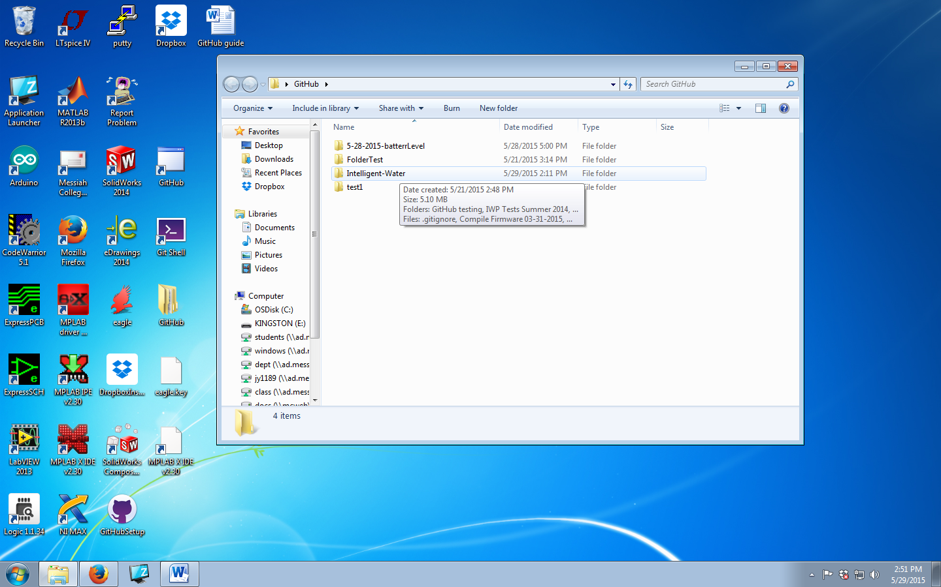

2) For this folder/branch to appear online, there must be a document inside the folder.

